## **Pinance Trading Platform**

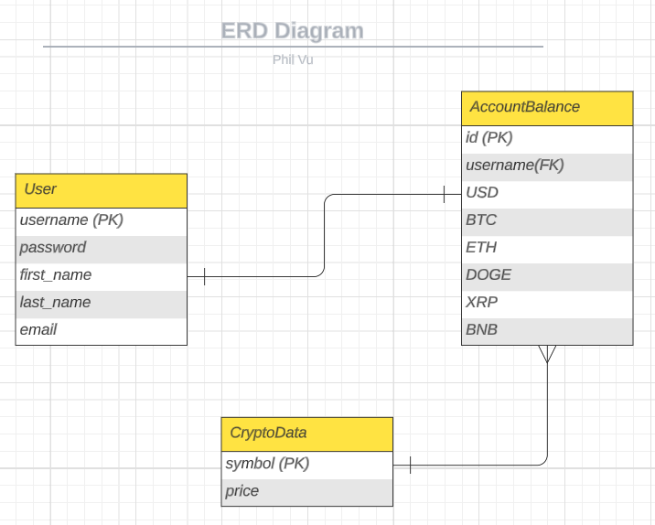

Welcome to the Pinance Trading Platform! This user guide provides an overview of the features and functionalities available to users.

### **Account Registration and Login**

To access the Pinance trading platform, users need to register for an account and then log in using their credentials. Here are the steps:

**Account Registration**

* Visit the Pinance website.
* Click on the "Register" button.
* Fill out the registration form with the required information, including username, password, email, and personal details.
* Submit the form to create your account.

**Login**

* After successful registration, navigate to the login page.
* Enter your username and password.
* Click on the "Login" button to access your account.

### **Account Management**

Once logged in, users have access to various account management features. Here's what you can do:

**Account Balance**

* Check your account balance to view the available funds for trading and investments.

**Deposit and Withdraw Funds**

* Deposit funds into your trading account to increase your available balance.
* Withdraw funds from your account to transfer money back to your bank account.

### **Crypto Trading**

Pinance trading platform allows users to buy and sell cryptos. Here's how it works:

**Market Overview**

* Access the market overview to view the latest crypto prices, market trends, and company information.
* Stay updated with real-time data and news to make informed trading decisions.

**Buy Cryptos**

* Search for the desired cryptos using their ticker symbols.
* Specify the quantity of cryptos you wish to purchase.
* Execute the buy order, and the system will deduct the corresponding funds from your account balance.

**Sell Cryptos**

* Select the cryptos from your portfolio that you want to sell.
* Specify the quantity of cryptos you wish to sell.
* Execute the sell order, and the system will credit the corresponding funds to your account balance.